TSC 2012 TUCSON CONFERENCE
ARCHIVE

Link to 2012 Abstracts / Program

The 10th Biennial
Toward a Science of Consciousness
April 9-14, 2012 TUCSON, ARIZONA
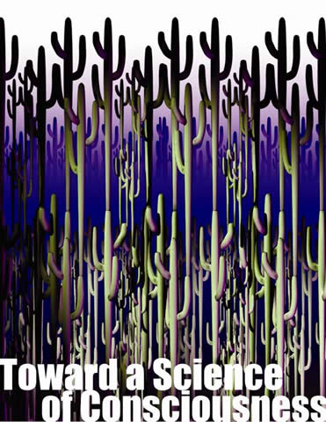

Many Thanks to all of our Speakers,
Participants & Volunteers - April 2012!

War of Worldviews Debate - 12 min. teaser
Eastern Philosophy Forum
Forum Outline and Facilitator Information
Forum - Program Schedule**
Deepak Chopra Workshop and Dinner
Chopra Workshop (Neuroscience of Englightenment)
Pre-Conference/Workshops/Forums
- Neuroscience of Music
- Cross Modal Consciousness-Synesthesia.
- Pranahuti Aided Meditation
- The Survival of Consciousness After Death Hypothesis
- Exploring Frontiers of Mind Brain Relationship
- Functional Neuroimaging of (Un)Consciousness
- Philosophical Overview of Theories of Consciousness
- Quantum Consciousness Update
- Exploring Frontiers of Mind Brain Relationship part 2

CONFERENCE SESSIONS
TSC 2012
Plenary Sessions (Schedule and Abstracts)
Concurrents

Poster Sessions
Art-Tech-Health Demos
CEU's
University of Arizona Continuing Education 5.2 CEU Credits
Late Registration Fees (after March 15, 2012
$495 Standard $395 Student $295 Spouse/Partner
TSC Abstract Submission System
TSC Abstract Template and Taxonomy /GUIDE
2012Ad/Flyer
Refund Policy - see registration form
Exhibitor-booths
Other Methods of Payment
Online Registration

TOWARD A SCIENCE OF CONSCIOUSNESS 2012

POETRY SLAM / ZOMBIE BLUES
featuring THE ATOMIC GADGETS

FRIDAY April 13, 2012
9:45 pm - 12:30 am
Grand Ballroom
cash bar - following the Friday Poster Session and Art-Tech Health Demos

Evening Openers and Schedule
9:30-9:45 Warming up with the Atomic Gadgets
945 The Conscious Comic
10:00 Poetry Slam
11:00 Zombie Blues Band
TSC'ers jam with the Atomic Gadgets
11:15-11:45 Performances of Zombie Blues renditions with back up
from the Atomic Gadgets
11:45 -12:30 THE ATOMIC GADGETS - Music and Dancing

Poetry Slam / Zombie Blues
As in previous conferences, this is a poetry slam/ Zombie Blues talent non-reality show.
TSC Attendees are invited to recite an original poem on any topic related to consciousness
to a cheering and sometimes jeering audience. Following the poems, attendees offer one
or more verses of the Zombie Blues with musical accompaniment by THE ATOMIC GADGETS

The original soulless lament:
"I act like you act, I do what you do, but I don't know what its like to be you.
What consciousness is... I ain't got a clue....I got the Zombie Blues

ADD YOUR OWN VERSES.....
You are all invited to write your own verse to the Zombie Blues and to have the stage for a 3-minute gig - sign the message board at the registration desk and let us know by Fri morning if you wish to perform.

Some scenes from past Zombie Blues

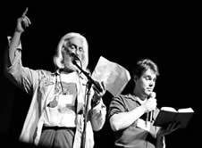
Poetry Slam winners: 2008 Rutherfords
The Rime of the Conscious Mariner

MORE PHOTOS from the past

| | Mission | | | People | | | Archives | | | Web Courses | | | Resources | |

Center for CONSCIOUSNESS STUDIES  P.O. Box 210068  Tucson, AZ 85721-0068  USA | phone: 520-621-9317  fax: 520-626-6416  email: center@email.arizona.edu

